Playful and compassionate approaches for inclusive Information Literacy instruction

Andrew Walsh. @Playbrarian (on most social media)

<https://playbrarian.uk/>

This is a summarised version of the Keynote talk I gave at LILAC conference, March 2024 in Leeds, together with selected quotes and images from the playful and reflective exercises we did during the session.

This covers material on play, playfulness and playful learning, moving onto compassionate pedagogies, then a little about what I see information literacy instruction as being for – hopefully showing the three areas are linked by a common strand throughout.

**Games** are the “structures” I take to teaching sessions sometimes to try and enable play to emerge. They tend to consist of a **goal** (an end point, something that signals the game is finished or won), a **set of rules** (that are artificial restrictions we put on ourselves and follow to allow the game to progress towards the goal), and **a feedback system** (some way of knowing how the game is progressing, how well we are doing, or if we’ve managed to achieve the goal). But it’s important to note that I can make people take part in a game, but whether they are genuinely playing or not is a different matter – so games are something I use that are a convenient way of trying to bring play about, but the rules, the structures, the game itself isn’t as important as any play that might happen.

"to play a game is to engage in activity directed toward bringing about a specific state of affairs, using only means permitted by specific rules, where the means permitted by the rules are more limited in scope than they would be in the absence of the rules, and where the sole reason for accepting such limitation is to make possible such activity.“ (Bernard Suits)

**Play** is the act itself. It tends to be **Apparently Purposeless** (done for its own sake), **Voluntary** (you can’t force people to play, even if you can force people to go through the motions of a learning game), it **has Inherent Attraction** (if you see people playing, there is a strong temptation to join in); along with this it has **Continuation desire** (once you start playing, there is a tendency to want to carry on), it often brings a sense of **Freedom from time** (you can lose track of time, “time flies when you’re having fun!”), incredibly useful for learning, it brings a **Diminished consciousness of self** (you can step into different roles, see things from other points of view, and be freed up to say or do things you might otherwise be too self-conscious to do), and really importantly, it always has **Improvisational potential** (the players have a certain element of power, able to change the rules to suit themselves – different to a formal or competitive game or sport).(List from Brown & Vaughan)

I use games as a vehicle to enable play to happen, but I also come at it from another angle – **Playfulness.** This is quite literally “full of play”, a mental attitude that is likely to spill out into play, fun, or humour. There are lots of ways of encouraging playfulness, I did some very easy things during the keynote, like passing blank books around the lecture theatre – the first one (quotes below) asked how people used playful approaches, the second was a similar question about compassionate teaching. I encouraged people to write, draw, whatever they felt like doing in the books – as they moved around the room each person could see what the others had done, and in many of the books the entries got more creative and playful. You could sense the permission they felt by seeing what others had done. I use lots of different approaches to encourage this sense of playfulness in my teaching.

When I talk to people about playful learning and teaching, I often ask what they think they benefits are – people often come up with sensible suggestions like fun; engagement, making sessions more memorable, etc. What rarely comes up are some of the benefits I see as most powerful:

Play can help to **shift power dynamics**, letting learners take some of the power and control from me as the teacher, letting them adapt content and structures of a session, which includes naturally **increasing inclusivity** as when we genuinely play, we naturally try to ensure all players can take part. It can **allow people to see things from other points of view**, and express ideas that they otherwise they wouldn’t feel confident in doing, something I see as important when I’m asking them to develop their *critical* information literacy skills. Finally, it encourages creativity, something I see as important for undergraduates as they find new ways of being and transform themselves through university, but also for researchers that I support – what is research if not an aspect of creatively exploring new areas of knowledge?

**A small proportion of selected quotes from the notebooks – How I am, or how I could be, playful in my teaching:**

“I’d want to show my humanity with playfulness”

“Think about the needs of students more! Get them to do Mexican waves or things to wake them up!”

“Otter ballpools – more of them!” together with a drawing of an otter ballpool. (Note – this is an in joke from another conference, showing they felt free to play, draw, and joke!)

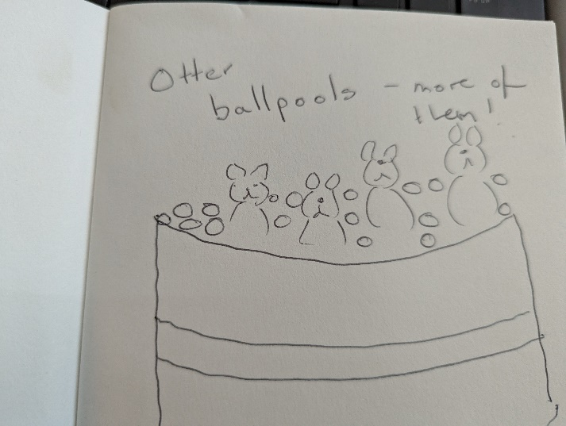

“I use memes or images (or an object, sometimes) as it’s universal among students who may not have the same level of English.”

“Participatory approaches to ensure

We attend to

Safety

Connection

Creativity

And

Hope

The Creative Library is inspired by Andy’s work on play.”

“Book spine poetry”

“Found ways to get a laugh out of OSCOLA referencing 😊”

“Remembering that we’re people not meeple! Not workers to be placed, and different people will behave very differently in the same situation – so bend the rules to suit the players.”

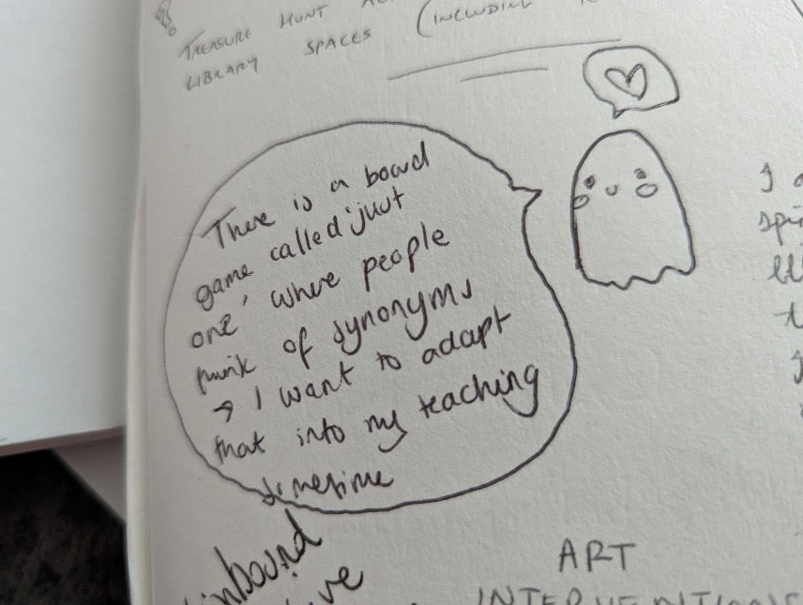

“I often deliberately (or not!) mess things up both to show we all make mistakes and to get a laugh and engagement from students.”

“Don’t take myself too seriously! Embrace messiness, don’t be afraid to poke fun at myself.”

**Next we move onto compassionate pedagogies.** I first started to think about this after working with an education lecturer a few years ago who borrowed the terminology of “professional love” (see Jools Page’s research and writings on this). Professional love normally refers to early years practitioners, people like nursery workers, who are paid to look after children, but who also love the children in these professional settings. My former colleague railed against the political and financial demands of modern higher education trying to force us to think of students as numbers, as potential profits (or losses) to an institution, as blank slates to turn into “good little citizens”, with the idea being them earning high wages and not rocking the boat. He asked instead why he couldn’t love his students, and this drove his approach to teaching, with something that we’d normally call a **compassionate pedagogy.**

There is lots of variation in this, it’s value driven approach to teaching more than a firm set of instructions! But at it’s core it asks us to aim to recognise the distress that students can feel in our learning environments and try to minimise that. Also to actively try to reduce disadvantage. But above all, centring ideas of compassion towards our learners.

Compassionate Pedagogy is “a pedagogical commitment that allows educators to criticize institutional and classroom practices that ideologically place underserved students at disadvantaged positions, while at the same time be self-reflexive of their actions through compassion as a daily commitment” (Hao, 2011)

It’s hard to give too much detail as it *is*more values than instructions, but it will typically look like:

* Students being genuinely listened too & valued.
* Empowering students to be who they are, celebrating diversity rather than driving towards conformity.
* Create safe environments for learners.
* Building relationships (which I know is hard for librarians and information literacy teaching as we may only see people once!)

**A small proportion of selected quotes from the notebooks – How I do, or how I could, show compassion to my learners:**

“Extend grace and the most generous interpretation – this is (usually) everyone’s first time through life. “

“Recognize the ever increasing cost / expectations (hidden & overt) in higher education, validate those experiences, leverage library resources to support learners in ways that are meaningful to them – support participation in whatever way makes sense for them. Identify and unpack power.

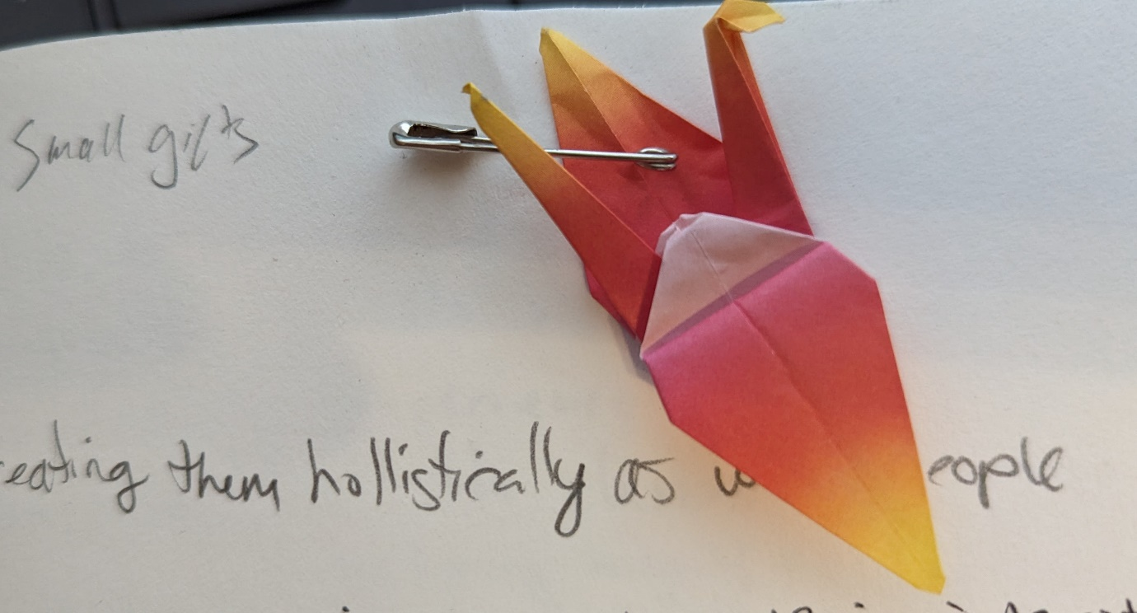

Photo above titled “small gifts”.

“I may not understand where you come from, but I am trying to.”

“Remember to ask ‘how are you?’ each time you see them.”

“…ask them what their needs are and focus on what they need to find”

“Ask & listen & care ”

Putting **Playful Learning** and **Compassionate Pedagogies** together, I’d ask “can we play without love, without compassion?” I suspect not. They also both have significant overlap, especially in areas like:

* Moving power to the learner from the instructor.
* The ability to adapt content and structures of sessions to overcome any barriers identified.
* Hearing (and valuing) all voices involved.

We then go to our third area, **information literacy teaching** specifically.

Most definitions of information literacy are deliberately angled towards the idea that it is relational, contextual, not an “absolute” thing. There is *not* one way of being information literate and it’s always different in different contexts… but often librarians don’t approach it in that way.

Especially in Higher Education and librarians teaching being done at the invitation of lectures, module or course leaders, there is a tension between what a lecturer thinks should be taught (and how it is taught) and what the students actually need. What we actually teach is often on a spectrum between these two, with many people falling towards the “what lecturer says” end of the spectrum, though I readily admit I will normally fall further towards the “what students need” end. I want learners to leave any teaching session I run to feel they are more confident in the skills they have to meet whatever *they feel* they need to do to be information literate in that context, for that assignment, as part of a balance between all the other tensions on their work, study, and home lives. I don’t expect them to search, evaluate, organise, etc information in the same way that I would, or in some sort of hypothetically perfect way.

So pulling everything together, I’d suggest that our information literacy teaching should be more learner centred than it often is at present. This fits nicely with shifting power to the learner & compassionate approaches, along with playful learning approaches. For me, it’s all part of the same whole, but I’d like to stress that I’m not saying it’s the only answer – just **a** correct answer for me. There are as many correct answers as there are people in this room, but to be “correct”, we should make sure that what we think that information literacy teaching is **for**, is aligned with how we approach teaching it. Our pedagogies should be aligned with our values and ethics.

**References**

Brown, S. & Vaughan, C. (2010). *Play: How it shapes the brain, opens the imagination, and invigorates the soul.* Penguin.

Hamilton, L. & Petty, S. (2023). Compassionate pedagogy for neurodiversity in higher education: A conceptual analysis. *Frontiers in Psychology*. 14. <https://doi.org/10.3389/fpsyg.2023.1093290>

Hao, R.N. (2011). Critical compassionate pedagogy and the teacher’s role in first-generation student success. *New Directions for Teaching and Learning*, 2011(127), pp.91–98.

McGonigal, J. (2012). *Reality is broken: Why games make us better and how they can change the world*. Vintage.

Suits, B. (1978). *The grasshopper: Games life and utopia*. Broadview Press.

Andy Walsh, March 2024

<https://playbrarian.uk/>

After thought – we did one final reflective exercise, using an AI drawing app within padlet (called “I can’t draw”) to ask people to sum up the keynote for them. A few images from that follow, together with the prompts used:

(Note – there were **lots** more kittens, most of which didn’t include their prompts.)

A pile of colourful blocks


Prompt: Play as an inclusive tool



Prompt: Information literacy plays wild games



Prompt: Librarians rebelling against authority



Prompt: A round table as leveller between teacher and students, shifting power dynamics, and students having fun playing a marble game.



Prompt: a diverse group of young adults playing a library-themed boardgame while smiling and laughing

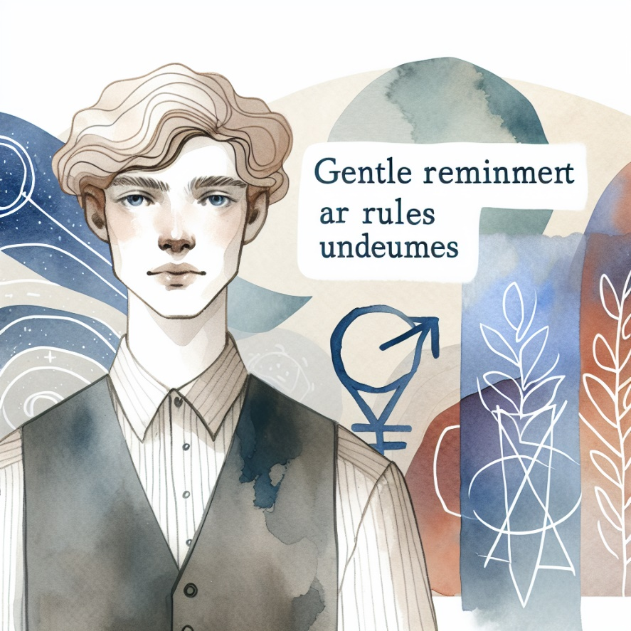

Prompt: A queer person reminding you of the rules

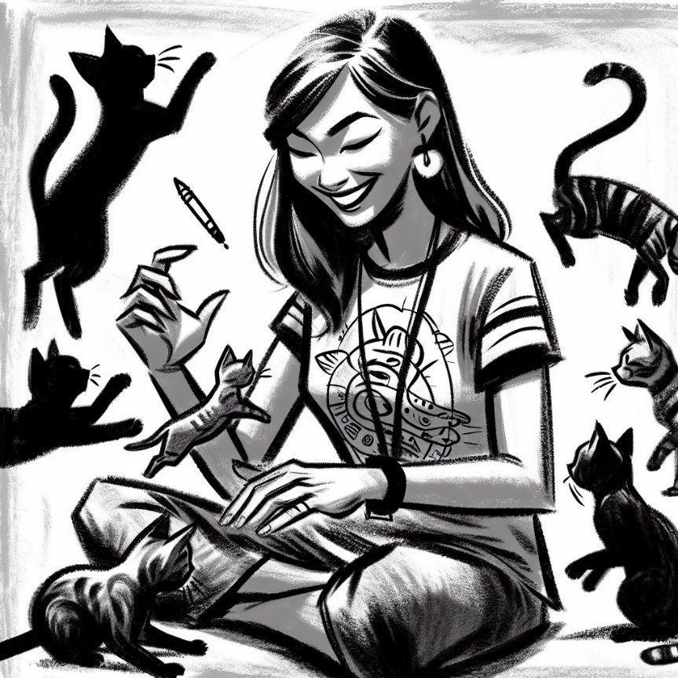

Prompt: Teaching copyright through t-shirts, cats and play



Prompt: Playful and compassionate